Effective behaviour management - positive framing

Key concept(s)
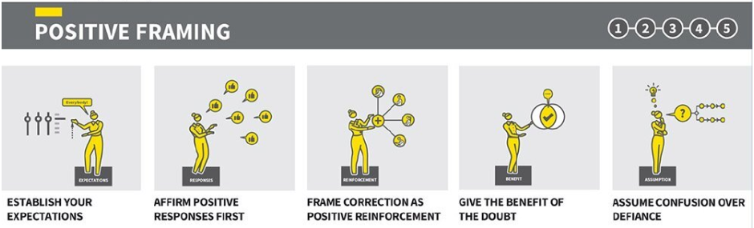

Caviglioli and Sherrington (2021)

In today’s observation, we will focus on positive framing. Specifically:
- affirming positive responses
- framing correction as positive reinforcement

Before the observation, take time to understand what is meant by positive framing.
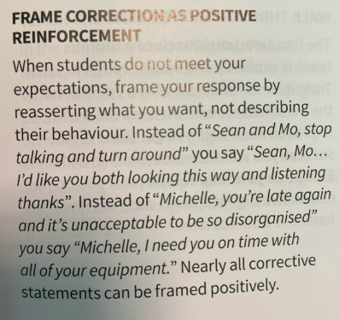
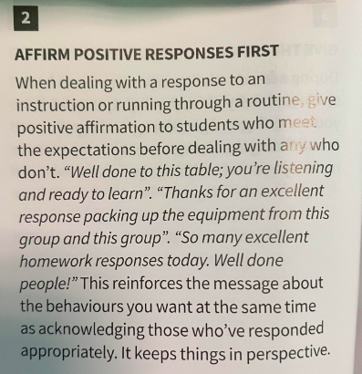

Reflect: to what extent would you say that positive framing is a technique you adopt in your own practice?
Before you observe [teacher], ask her to note down some of her expectations for learners during routines or instructions. Ask [teacher] to choose a routine (or routines) that will be relevant to the observation (e.g. expectations for speaking tasks, expectations for using certain equipment, etc).
Expectations for instructional stages
Expectations for __________________

Expectations for __________________

During the observation
Identify moments during the lesson when learner behaviour does not meet expectations. Make notes in the table below. Try to capture the exact wording [teacher] used when addressing learner behaviour.

Learner behaviour  (how did learner behaviour not meet expectations?) | [teacher]’s response  (How did [teacher] address this? What did she say or do?) | Learner reaction  (Did learner behaviour change? How did they respond to [teacher]?)
Learner behaviour  (how did learner behaviour not meet expectations?) | [teacher]’s response  (How did [teacher] address this? What did she say or do?) | Learner reaction  (Did learner behaviour change? How did they respond to [teacher]?)

Find time to discuss your observations with [teacher]. You could explore:
- To what extent did [teacher] use positive framing to address unfocused behaviour?
- How effective were [teacher]’s techniques for dealing with unfocused behaviour?
- Were some techniques that [teacher] used more effective than others?
- Were they any techniques you observed that you thought would instantly enhance your own practice?
- Caviglioli and Sherrington (2021) state that ‘nearly all corrective statements can be framed positively’. Do you agree, and do you think positive framing is always best practice?

When you finish, add your reflection to the box.

Possible enhancements to my own practice:

