Effective behaviour management - getting all learners’ attention

Key concept(s)

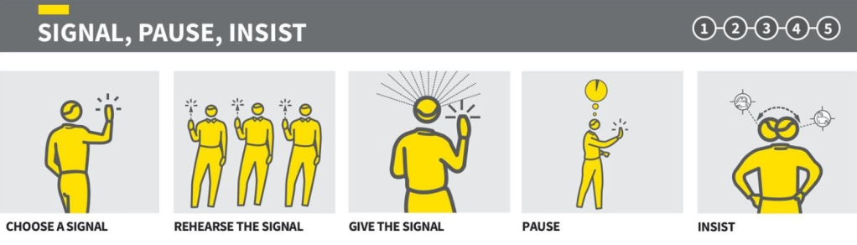
Caviglioli and Sherrington (2021)

In today’s observation, explore the ways in which [teacher] is able to:
- get the attention of all learners
- insist/expect that learners remain attentive

Read through the focus questions in this table before the observation. Be ready to record notes as you observe.

How does [teacher] signal to the learners that an instruction is beginning? Think about: Gestures and body language, changes to voice, key phrases used consistently, etc. Draw examples if it helps!
What strategies does [teacher] use to maintain this attention?
Think about: pausing, use of voice, use of gestures, dealing with low level disruption during the instructions, etc
Observe the learners. How do they react to [teacher]?
Think about: changes to learner behaviour, body language, understanding what’s going on, individual learners reactions, etc

Find time to discuss your observations with [teacher]. You could explore:
- What you liked / What worked well
- What the learners didn’t respond so well to, and why?
- The purpose of each strategy [teacher] used - what was the WHY?
- [teacher]’s strategies you already use. Are they effective for you?
- [teacher]’s strategies that you’d like to try.

When you finish, add your reflection to the box.

Possible enhancements to my own practice:

