Advertising Brief
We’ve been contacted by a leading producer of soymilk products to create a new viral ad campaign for an existing product. Your role is to outline a potential campaign for the company, which will be pitched to the client’s marketing team.
About the client
Lactasoy were founded in 1950, originally producing dairy products. They converted their production to soymilk products in 1981 and have been the market leader in Thailand ever since.
- The company have a strong commitment to creating products with excellent quality and highest nutrition.
- The company have a strong reputation for sincerity among customers and business partners
- They are widely recognised as the best soymilk manufacturer, due to their careful selection of quality ingredients
- Lactasoy use advanced technologies to produce their products and are known as the most hygienic food producers in the region
- Lactasoy have been voted ‘Top Brand’ at the Marketeer Awards for the last three years. Last year they made 1,600 million baht in total sales (as reported by the Bangkok post).
Previous advertising campaigns
Lactasoy’s dominance in the market means competitors are limited. They don’t usually advertise comparing themselves and their benefits to other, similar brands.
The strong brand image of Lactasoy has been built on successful advertising campaigns, notably those including the ‘Lactasoy jingle’. Examples can be found here:

This musical format, first devised by our rivals at Major Advertising, has been a strength of the brand. One of the most recent versions, featuring the popular group BNK48, has received over 60 million views on Youtube to date. The video has also featured on public transport around major cities such as Bangkok, with consumer feedback overall being positive. The company will continue to use this jingle to appeal to younger generations.
Recently, the company have made use of BNK48 in static advertising too:
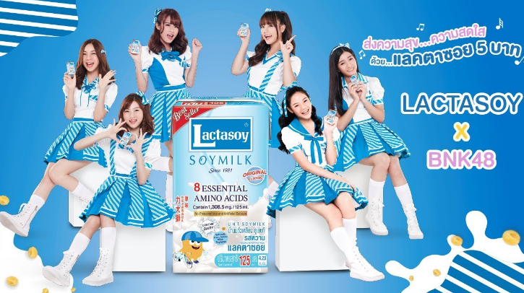
However, consumer feedback has shown that these static adverts (e.g. posters on public transport and shopping centres, billboards, etc) have proven less popular. Their target audience for static advertising is slightly older than those for video campaigns, and feedback shows older generations associate less with BNK48.
One area where the company would like to improve their marketing is on social media. While the BNK48 adverts have proven popular and have been widely shared, Lactasoy have been disappointed in recent years by their lack of presence on platforms such as Facebook, Instagram and Twitter. In fact, they have virtually no presence on Twitter, and despite having a Facebook page with over 500,000 followers, their posts receive only around 100 likes and 50 shares on average.
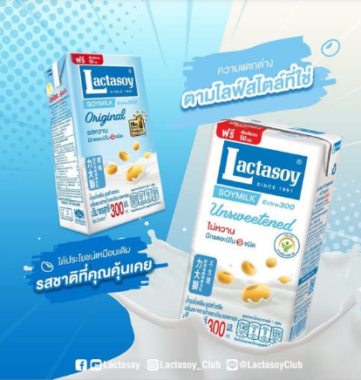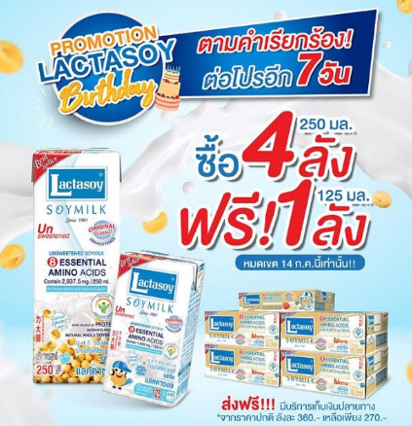
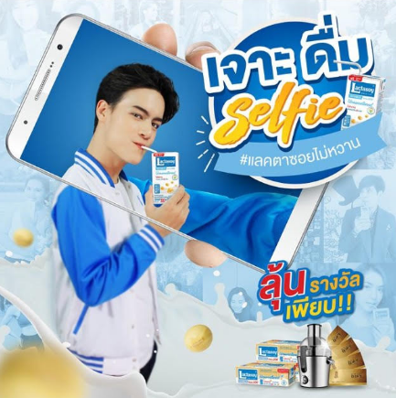
The main complaints from the company about previous campaigns on social media are that the adverts are usually simplistic, lack engagement, and focus mainly on promotions rather than the USPs of the product itself.
……………………………………………………………………………………………………………………
Your brief
The company would like to create a social media and video campaign as an addition to their existing ‘Lactasoy jingle’. This campaign will still be aimed at younger generations. The new campaign will aim to:
- promote the health benefits of Lactasoy for older generations
- promote the social responsibility of younger generations (particularly young adults) in caring for older generations
- emphasize the ingredients and quality of the product, and how these contribute a person’s health
- focus primarily on ‘Lactasoy Unsweetened’. This is the product with the lowest sales in the Lactasoy range.
Deliverable
The company would like you to pitch ideas on the following:
- A series of promotional posts on social media (Facebook, Twitter and Instagram), which will be released across a 3-month period. A minimum of three posts are needed.
- One video advertisement (storyboarded in 6 frames) highlighting how younger generations can help older generations to stay healthy (i.e. by drinking Lactasoy products)

Additional information
- The company have been reluctant to use memes in any of their previous campaigns. You may wish to create a meme, but we feel you will need a strong rationale behind choosing this format to convince them that it will be a success.
- The company have confirmed that BNK48 are available for this advertising campaign. However, they come at a high cost. You can pitch ideas either including BNK48 or without them, but it is worth considering whether they would actually appeal to the target audience.
- The company have not given us a specific budget for this campaign. However, we assume that the budget is low, given the high costs involved in the Lactasoy’s other campaigns. Our advice is: don’t aim for a high budget – consider this when deciding things like filming locations, actors, copyright for existing images, etc.
- Above all – don’t forget the brand logo. This should be a prominent part of the campaign.
