Learning objective: Predicting content of a story based on visuals

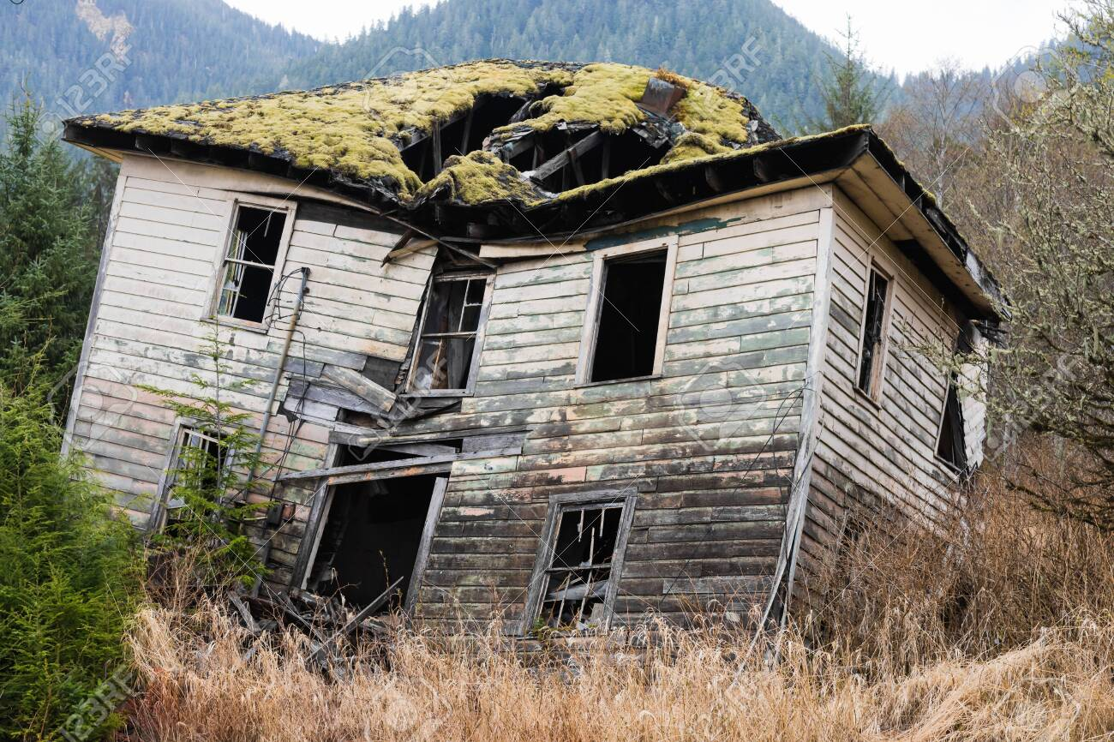
- What can you see? Write 10 words in the box (or label the image).

- Complete the sentences with your own ideas:

- The house looks…
- The house is made of…
- The windows are…
- The garden is…

- Imagine... you hear a noise coming from this house. What could it be? Think of 3 ideas.

It might be _________________________ because …
It could be _________________________ because …
Maybe it’s _________________________ because …

- Make quick notes in the table, you don’t need full sentences.

We should enter the house because... | We shouldn’t enter the house, because...

Listen to your teacher’s instructions.
Learning objective: Understanding key facts; identifying important information

- Read the text then answer the questions.

- How many characters are there? What are their names? What do you know about them?

- Who wanted to enter the house?

- Who didn't want to enter the house?

- Who entered the house?

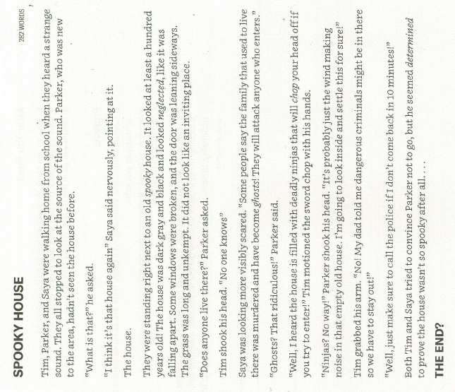

- Read the text again. Decide if the statements are true or false. Highlight where you found this information in the text.

1. Parker had only been in the neighbourhood for a short time.
2. Parker doesn’t believe what Saya says about the house.
3. Parker thinks that something natural is making the noise.
4. Tim’s father warned him about the house.
5. Parker believes one of Tim’s stories.

- Ask your partner quickfire questions about the text. They answer from memory. Examples:

Q: What were the students doing when they saw the house
A: Walking home from school

Q: What did they hear?
A: A sound
Q: What type of sound?
A: A strange one!

- Work with a partner. Discuss the questions.

Why do you think Parker is willing to go in the house?
'I think Parker is willing to go in the house because...'

Why do you think Tim and Saya don't want to go in?
‘Tim and Saya don't want to go in because...'

Would you go in the house? Why / Why not?
‘Personally, I would / I wouldn't go in the house, because...'

- Work in a group of 4. Decide who has the following roles:

Role 1: Narrator
Role 2: Tim
Role 3: Saya
Role 4: Parker

Narrator - read the text aloud.
Other characters - say your lines when needed!

Learning objective: Guessing the meaning of unknown words from context

- Find and highlight the following words in the text:
- neglected
- convince
- visibly scared

- Choose the correct meaning for each word. Explain your thinking.
‘I think neglected means…
a) not modern.
b) not taken care of.
c) scary.

I think this because… (read the text again to help you)

‘I think convince means…
a) try to change someone’s mind.
b) force somebody to do something.
c) have the same idea as somebody.

I think this because… (read the text again to help you)

- Find out what the word visible means. Use a dictionary if needed:

Definition: _________________________________________________________

Now describe three ways that someone might be visibly scared.

• ____________________________________

• ____________________________________

• ____________________________________

- Guess the meaning of the phrases in italics. Share your ideas with a partner. Then use a dictionary to check. (If you already know the word, explain that in the box).

Word/phrase | What I think it means... | Actual meaning / Was I correct?
… he seemed determined to prove the house wasn’t spooky after all... | I think determined means...
… it didn’t look like an inviting place... | I think inviting means...
...the house is filled with deadly ninjas... | I think deadly means...
(your own unknown word)

- Word building. Complete the table by adding the correct word forms. There might not be an example word for each box.

noun | verb | adjective | adverb
 | (meaning may be different!) | determined
 |  | inviting

- Discuss these questions with a partner.

- What would make a house inviting?
- Have you ever been determined to do something? (e.g. win a competition, pass a test, etc)
- Which deadly animals do you know?
- Do you know of any diseases or viruses that are deadly?
- If someone is visibly upset, how might they show that? Would everyone show their emotions in the same way?
- Have you ever neglected to do something (household chores, homework, etc)? If so, what happened?

- Grammar….
Read the extract from the text and answer the teacher’s questions.

Tim, Parker and Saya were walking home from school when they heard a strange sound.

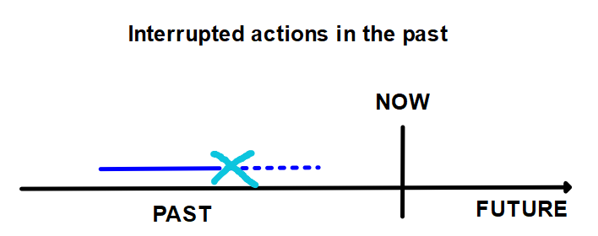
Add two labels to the diagram.
- walking
- heard a sound

Complete the sentences below with the correct verb form.

- I ____________________ (run) in the park when suddenly a snake __________ (fall) out of a tree and onto the path!
- She _________________ (drink) a glass of water when all of a sudden a cat _____________ (jump) on her lap and made her spill it!

Write your own sentence using this structure. Then perform a short, imaginary dialogue using it. Example:

A: I was walking down the street when suddenly I saw this massive car crash!
B: No way, what did you do?
A: Well, I ran over to help…
B: And then…
A: Well...

Task

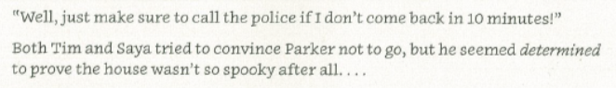

Parker didn’t return after 10 minutes. Tim and Saya called the police.

You are the police officer that arrives on the scene. What would you do?

First, I would…
Then, I’d…
I might…
I’d probably...

Imagine that you did those things. Imagine what happened. Tell your partner.

The first thing I did when I arrived was look at the house. I could see it was strange! I didn’t enter, first I spoke with Tim and Saya. They explained that…

Complete your police report about the incident.

Police Dept: | St Andrews 107 | Officer Name:
Date: |  | Time:
Location: | Spooky House | Reason for visit: | Call from two school children worried about a friend.
Officer statement:

Content
[What did you see when you arrived at the scene]
[What did you do?]
[What happened?]

Language
[Can I show consistent use of past tenses?]
[Can I use any of the new vocabulary from this story or the lesson?]
[Can I use the past continuous for interrupted actions?]

Success criteria | YES/NO/Comments
Content
Did I describe what I saw when I arrived at the scene?
Content
Did I explain my actions and what happened?
Language
Was I consistent when using past tenses?
Language
Did I include any new words or grammar structures in my report?

