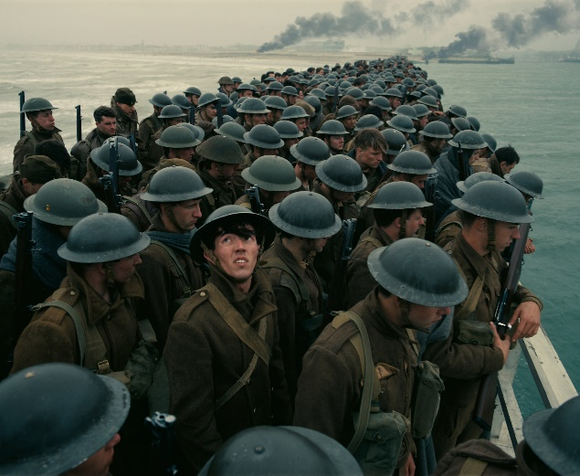
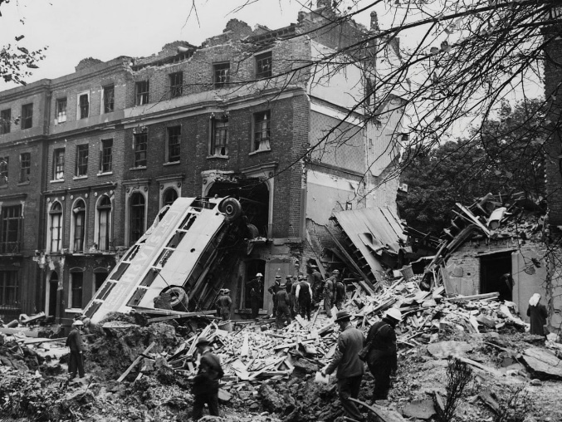
Unscramble the word related to each scene.
2
1
RNKIDUK HET TIZLB
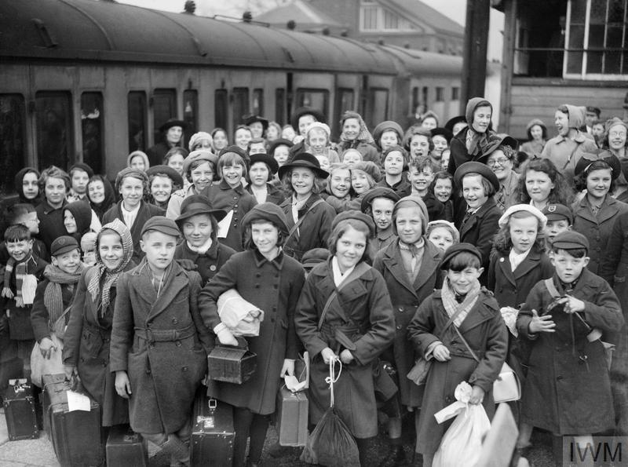
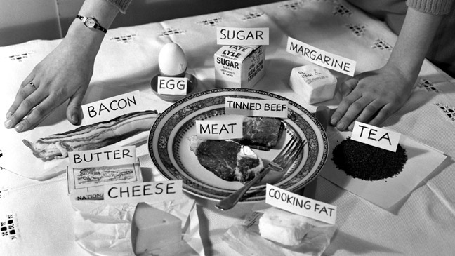
_________________________ ____________________________
4
3

TIONGNIRA VECUATOINA
_________________________ ____________________________

Look at the photos again. Number the words based on the photos.
troops countryside blackout
bombs evacuee Dig for Victory
miracle Operation Dynamo air raids

Add information to the correct space in the table.
 | Dunkirk | The Blitz
When?
Where?
Who?
What?
Why?

- The coast of France
- German bombing campaign on British towns and cities
- German bombers, civilian targets
- Major towns and cities in the UK
- Soldiers
- 1940-1941
- Destroy British morale and undermine the support for the war
- May 1940
- Mass evacuation of soldiers by sea
- Because the troops were surrounded and trapped by German army
- Add information to the correct space in the table.2
Complete the table with key information about the two events.
 | Evacuations during WW2 | Rationing during WW2
When?

Where?

Who?
What?
Why?

Match the words with a similar meaning.
escape trapped
surrounded flee
shelter bunker
ration limit

Draw the following:
confined space | roam
resistant | dehydration
pesticide | contaminate

Label each drawing based on the topic:
W = access to water
GM = genetically modified crops
B = battery farming

Write one sentence for each topic using one of the keywords.
- _________________________________________________

- _________________________________________________

- _________________________________________________
P.E.E. paragraph – write the point.
________________________________________________________
________________________________________________________.
For example, some crops are modified to make them resistant to pests. This means that the crops don’t need to be sprayed with chemicals. Those chemicals may cause harm to the soil, so not using them is a good thing.

P.E.E. paragraph – write the evidence and explanation.
Point: If is difficult to grow crows in certain parts of the world.
Evidence: ____________________________________
_____________________________________________
_____________________________________________
Explanation: _________________________________
_____________________________________________
__________________________________________________

Write the formula for speed.

Write the formula for finding the area of a triangle.

Write three advantages and three disadvantages to using GM crops. Skim-read the article if you need ideas.
Advantages | Disadvantages
 | 

What is a crumple zone?
_________________________________________________
_________________________________________________.

Brackets example: ( )
I example:
D example:
M example:
A example:
S example:

