LO: I can describe a place using fronted adverbials.

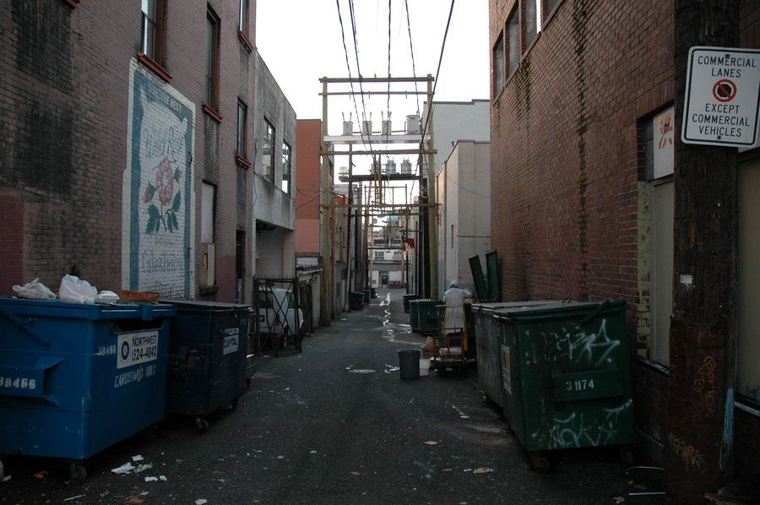
Rearrange the sentences to describe the photo. Remember to start with the fronted adverbial.

- from / I can see / trash / On the ground, / an overflowing bin

On the ground, __________________________________________

- On the building, / the light / I can see / windows reflecting
_______________________________________________________

- rotting meat / I can smell / in the bin / Next to me,
_______________________________________________________

In sentence 1, describe the trash. Add one word.
In sentence 2, describe the light. Add one word.
In sentence 3, describe the bin. Add two words.

Complete the sentences using ideas from the box.

graffiti the buzzing of hastily sprayed

dirty rain water a chef from a local restaurant under my feet

rustling through bins faulty electrical cables

High above, I can hear… the buzzing of faulty electrical cables.

On the dumpster, I can see …

Walking down the alleyway, I can feel…

In the open dumpster, I can see …

Choose one sentence above. Add more words to make it more interesting.

Choose one more item to describe in the picture:

the car the painting the bucket

Complete the box:

Where is it? | Can you see/smell/hear/feel it? | What is it? / What is it like? / What is it doing?

