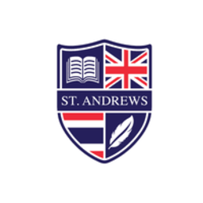
Reading Record Task 1 (Fiction)
Choose a chapter from the book you are reading. Storyboard the chapter in the four squares. Describe what happened under each square.
Draw the scene: | Draw the scene:
What happened? | What happened?
Draw the scene: | Draw the scene:
What happened? | What happened?
Reading Record Task 2 (Fiction)
Summarise the book you are reading. Complete each part of the chart below.
Book name
Author
Genre
Main characters
Synopsis
(max. 30 words)
Something I like about the book
Something I think could be improved
My rating
(colour the stars)
Reading Record Task 3 (Fiction)
Reach the end of a chapter in your book, or the end of the whole book!
What happens next? Continue the story for a minimum of 100 words. Try and write in the style of the author!
Book name:
Style/genre:
The story continued…

Word count:

Reading Record Task 4 (Fiction)
As you read, make a note of any new words. Add these words to the table below. Complete the information in the table for at least 6 words.
New word | Meaning and form (e.g. verb, noun, etc) | Translation | Example sentence
Reading Record Task 5 (Fiction)
Find two new words or phrases from this week’s reading. Complete the chart for each word/phrase.
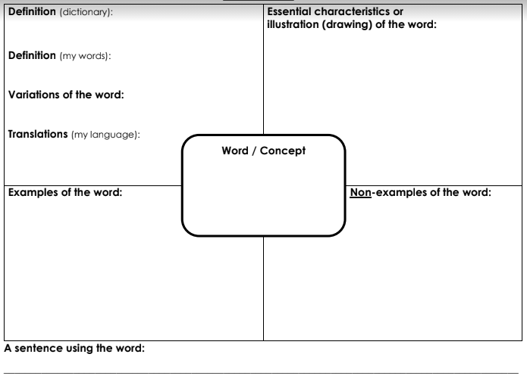
Reading Record Task 6 (Fiction)
Read 30 pages of your book. After every 10 pages, stop and write a tweet about the book. Remember, a tweet is only 140 characters long. Try to use all the characters, and don’t forget to hashtag!
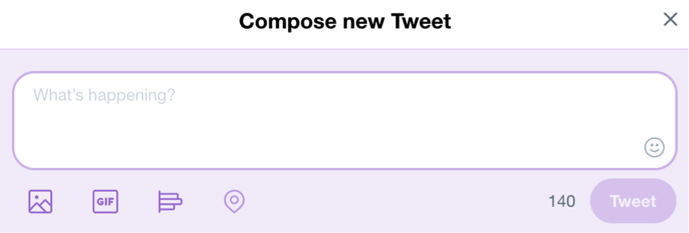

Reading Record Task 7 (Fiction)
Write a letter to the author of the book you are reading, or that you have just read. Include the following:
- Explain how you feel about the book
- Ask the author two questions about the book
- Suggest a way that the author could improve the book
Dear ____________

Yours sincerely,

Reading Record Task 8 (Fiction)
Read the next chapter of your book. When you get to the end, predict what you think will happen in the next chapter. Write a minimum of 50 words.

Now read the next chapter. Underline anything in your prediction that actually happened.

Reading Record Task 9 (Fiction)
Think about the book you’re reading, or that you have just read. Complete the table below, connecting the book to your own experiences.
A similar book I’ve read…
A similar feeling I’ve had to a character in the book…
A similar experience I’ve had to a character in the book (if any)…
Someone I know who is like one of the characters (in some way!)…
Something I learned from the book…

Something the book made me think about…

Reading Record Task 10 (Fiction)
The emotional rollercoaster of a book!
Think about your feelings while you read this book. Map them on the chart below. Explain how your emotions changed and why in the box provided.
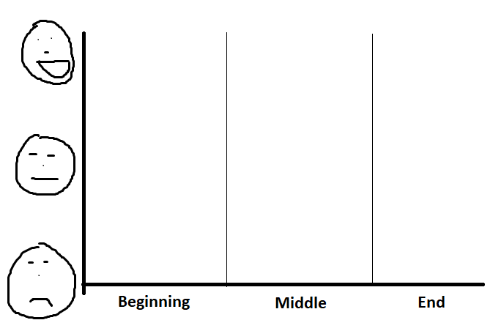
My feelings and how/why they changed:

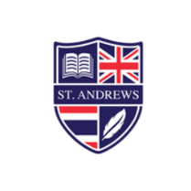
Reading Record Task 1 (Non-fiction)
Imagine you work for Blinkist…
This is an app that provides useful summaries of non-fiction texts. Summarise the key information from your book in the table below to share with Blinkist users…
Book name:

Summarise the book in 30 words:

5 key points from the book:

If you only learn two things from this book…

1)

2)


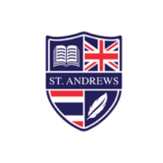
Reading Record Task 2 (Non-fiction)
Check-underline-question
Take a screenshot of one page from your book. Share it below. Then…
- Check (tick) any information you already know
- Underline any information that was new for you
- Annotate the page (well, the photo!) with at least two questions – what more do you want to know.
Insert screenshot here:


Reading Record Task 3 (Non-fiction)
Complete the KWL chart for your book topic.
- K – Know: Before you read, write down anything you already know about the topic of the book
- W – Want: Before you read, write down anything you want to know about the topic. Continue adding to this column as you read the book.
- L – Learn: During reading, and once you finish, write down anything you learnt about the topic.
Know | Want | Learn

Reading Record Task 4 (Non-fiction)
You meet someone who has no idea about the topic you have read about. How would you describe it to them in 100 words?


Reading Record Task 5 (Non-fiction)
How concise can you get?! Summarise a topic from your book in 50 words:

Now reduce that summary to 25 words:

Now reduce that summary to 10 words:

Now reduce that summary to 5 words!

Reading Record Task 6 (Non-fiction)
Grammar hunt! Find examples of all the following in your non-fiction book…
A sentence in the passive voice…

Three reporting verbs…

A sentence including the past perfect tense…

A sentence including the past continuous tense…

A sentence that includes a phrasal verb…

A sentence including a modal verb…

A complex sentence…

