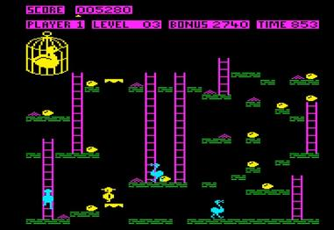
bbcmicro.co.uk

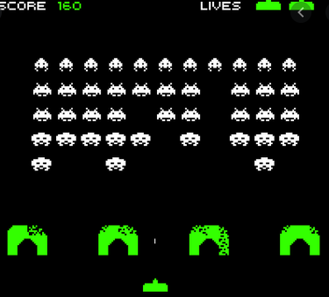
Smithsonianmag.com
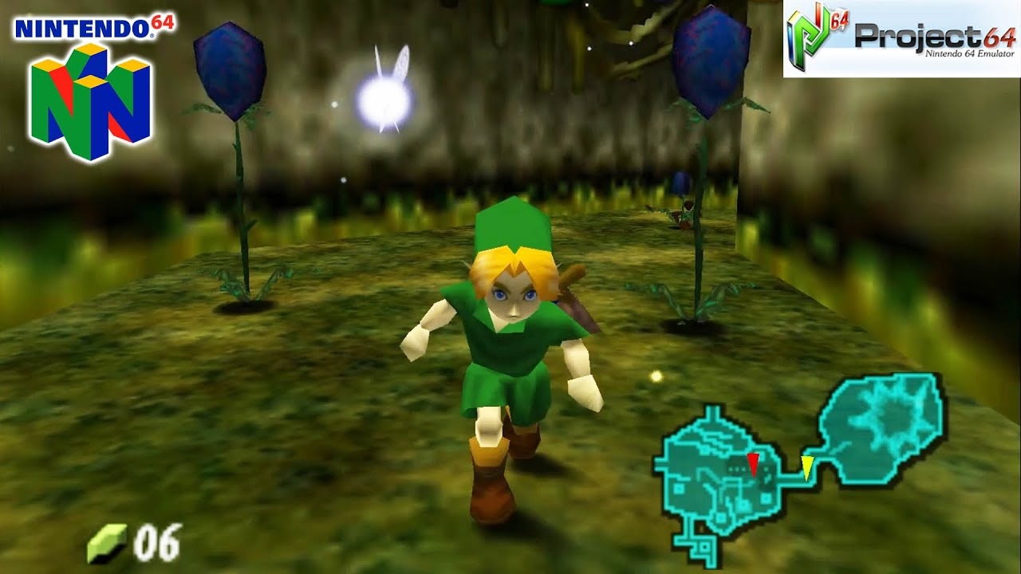
youtube.com

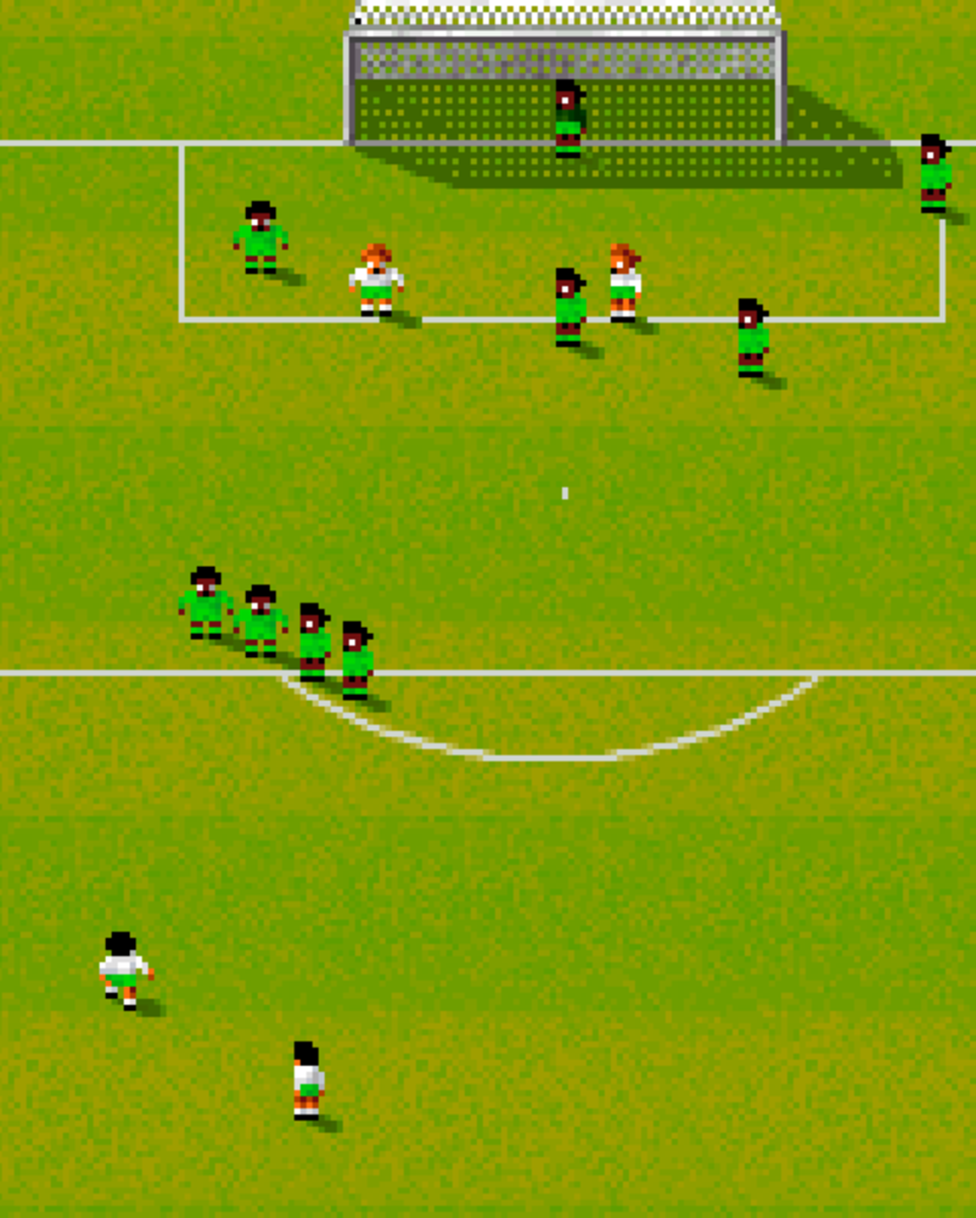
gamesnostalgia.com
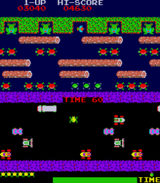
Wikipedia.org

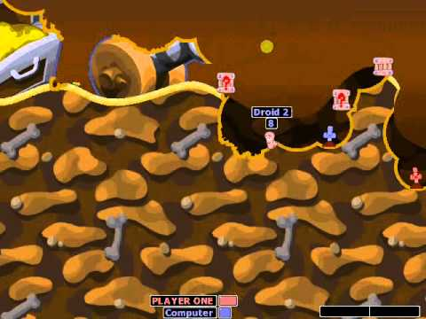
Youtube.com

Animationmagazine.net


Shacknews.com

Chuckie Egg

Space Invaders

House of the Dead

Mortal Kombat

Worms 2

Frogger

Zelda

Sensible World of Soccer

