Dave and Susan are old friends. They haven’t seen each other for a long time.
Read their conversation. Was Dave right to lie?
Susan: OH MY GOD! Hi! How are you?
Dave: Wow, good thanks, how are you?
Susan: Great! I haven’t seen you for years! What have you been doing?
Dave: I’m an actor now!
Susan: No way!
Dave: It’s true! I started acting a few years ago. I’ve been working in Hollywood since 2012.
Susan: Do you know George Clooney????
Dave: Of course, we’ve been doing Yoga classes together for six months now. We first met in June.
Susan: Really...?
Dave: Yeah, I visited his house yesterday
Susan: hmmm, I didn’t see you there
Dave: What?
Susan: George Clooney is my boyfriend. He’s been living with me for about three years. Where do you really work?
Dave: Burger King...
Susan: How long have you been working there?
Dave: since you left me for George Clooney.

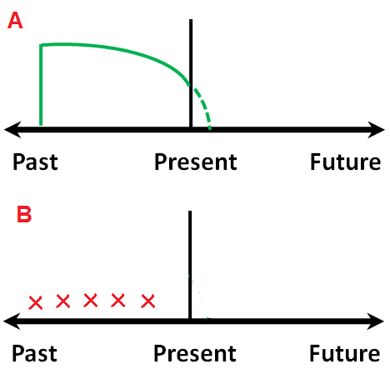
Look at these sentences from the text. Answer the questions, then match the timeline to the correct question
1. I’ve been working in Hollywood since 2012
- Does he work in Hollywood now? ________________
- When did he start working in Hollywood?_______________
2. He’s been living with me for about three years
- Do they live together now? _______________
- When did they start living together? ________________
3. We’ve been doing Yoga classes together for six months
- Do they do Yoga classes together now? ________________
- Have they done Yoga class together many times? ____________

How do we form the Present Perfect Continuous?
Choose one
I/you/he/she __________ been past simple (V2)
V + ing
past participle (V3)
Question form:
What/How long/Why + _____________ + Subject + been + _______________

Circle which verbs below can be used in the Present Perfect Continuous form
hate eat love be want play read
Are these verbs different? How?
_______________________________________________________________________________________________
_______________________________________________________________________________________________

Look at the example sentences. Choose the correct word below
We use FOR / SINCE to talk about a period of time
We use FOR / SINCE to talk about when an action started
Write ‘For’ or ‘Since; next to the time phrase:
- _________ a week B) __________ 1990 C) __________ twenty minutes
D) _________ he was born E) __________ Thursday F) ___________ then
G) __________ last week H) _________ nine o’clock I) ____________ this morning

Make a sentence from the words given. Use the present perfect continuous, and FOR/SINCE

- Study / English / five years 2. Live / Budapest / 2002
_I’ve been studying English for 5 years ___________________________________________

- Play / guitar / one month 4. Rain / this morning
___________________________________________ ___________________________________________

- Drive / about a year 6. Walk / four hours
___________________________________________ ___________________________________________

- Date / George Clooney / a week 8. Do / grammar / 30 minutes
___________________________________________ ___________________________________________

You will be meeting your old school friends! What have you been doing....? Be creative!

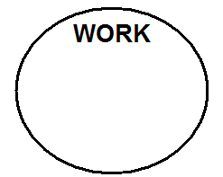
Think about:

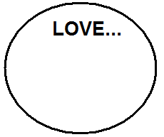

Now, find out about the other students. Who has had an interesting life since high school?





