
Martin’s trip to France
Martin and his wife Mina preparing to go on holiday. They are flying to France tonight for a romantic weekend together!
Read Martin and Mina’s conversation. Is Martin ready for the holiday?

MINA: Have you booked a babysitter yet? We can’t leave Elliot alone for the weekend
MARTIN: Don’t worry! I’ve already booked a babysitter. They will arrive at 5pm
MINA: Its 5.30 now – they still haven’t arrived
MARTIN: Don’t worry! Maybe they are stuck in traffic…
MINA: Hmmm, ok. Well I guess I should get ready. I haven’t packed yet
MARTIN: I’ve packed my bag already. I’m so excited!
MINA: Wow, you’re really organised! Are you sure you have everything?
MARTIN: Yep! Toothbrush, passport, money, a change of clothes. Everything!
MINA: Fine, well can you book a taxi?
MARTIN: I’ve already booked the taxi. It will be here at 7pm
MINA: Great! What time’s the flight?
MARTIN: Flight?! I thought we were taking the Eurostar…

Read the sentences in the table below. Choose the correct answer in each sentence
‘I haven’t packed yet’
We use ‘yet’ to say that something has / has not happened before now
‘Yet’ is normally used in positive / negative sentences

‘I’ve already booked a babysitter’
We use ‘already’ to say that something has happened before / after we expected
‘already’ is normally used with positive / negative sentences

‘They still haven’t arrived’
We use ‘still’ to say that something… A) has finished before we expected
B) is continuing longer than we expected
Look at the text again.
Underline all the sentences including the words ‘yet’, ‘already’ and ‘still’

What is the correct form? Put these words in the correct order: PARTICIPLE, ALREADY, SUBJECT, HAS/HAVE
_______________ + _______________ + _______________ + _______________

What is the correct form? Put these words in the correct order: PARTICIPLE, YET, SUBJECT, HASN’T/HAVEN’T
_______________ + _______________ + ________________ + _______________

QUESTIONS WITH ‘YET’… What is the correct form?
_______________ + ______________ + ________________ + ________________ ?
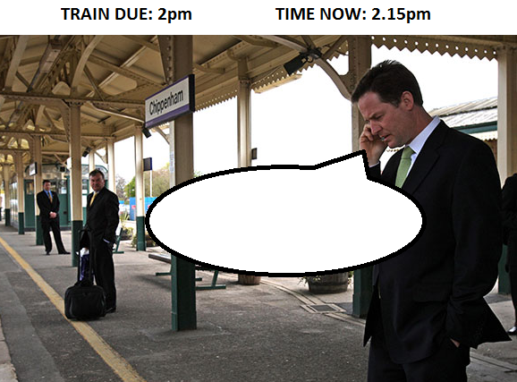
Now read the statements below then decide if a) or b) is correct.

1. John went to live in France 5 years ago and he lives there now.
a) He still lives in France.
b) He lives in France yet.

2. They haven't arrived. We expect them to be here soon.
a) They didn't arrive yet.
b) They haven't arrived yet.

3. She's unemployed. She's been unemployed for 3 years.
a) She still hasn't got a job
b) She's got a job already.

4. I've just finished eating dinner. I'm hungry.
a) I'm hungry yet.
b) I'm still hungry

5. He started looking for a job yesterday. He's starting work tomorrow.
a) He's got a job already.
b) He's still got a job.

6. She stopped eating meat 10 years ago. Even though she likes steak she doesn't eat meat now.
a) She doesn't still eat meat.
b) She still doesn't eat meat.

