Level: Higher Time: 90 mins Skills/focus: Speaking, Vocabulary, Study skills
Aims: By the end of the lesson will have given a presentation based on information from Google Trends.
Students will learn common vocabulary terms used in data analysis (steady increase, sharp decline, fluctuate, rise, peak, etc.)

Resources: Students need devices to view Google Trends online, at least one device per pair
A computer linked to a projector/IWB for the teacher to demonstrate activities is essential

Stage | Procedure | Time
Activate: create interest in the lesson resource  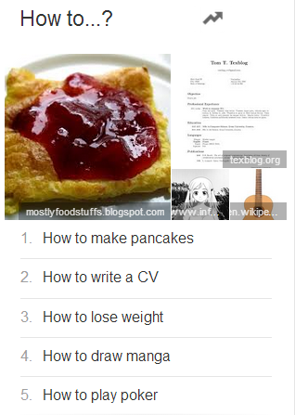 | Explain to students that today’s lesson will focus on internet trending.  Tell students that you can find stats for any search terms entered into Google, and compare them (see if they’ve heard of Google Trends).  Board ‘How to…’. Ask students to imagine they were typing this into Google – what would they say. Give an example: ‘How to make money’.  Pairs discuss, class feedback  Board the following:  How to make pancakes  How to write a CV  How to lose weight  How to draw Manga  How to play poker  These are the top 5 ‘How to…’ terms from 2013 in the UK  Question: Which search do you think was number 1?  Pairs discuss, feedback  Instruct students to go to Google Trends, ‘Top Charts’, and find the list.  Question: were you right? (note: the order above is actual top 5!)  Ask students to explore the other ‘Top 5’ charts for a few minutes together  Q: are you surprised by any of the search items?  Open discussion about Google Trends | 3 mins  2 mins  2 mins  5 mins
Introducing main task resources  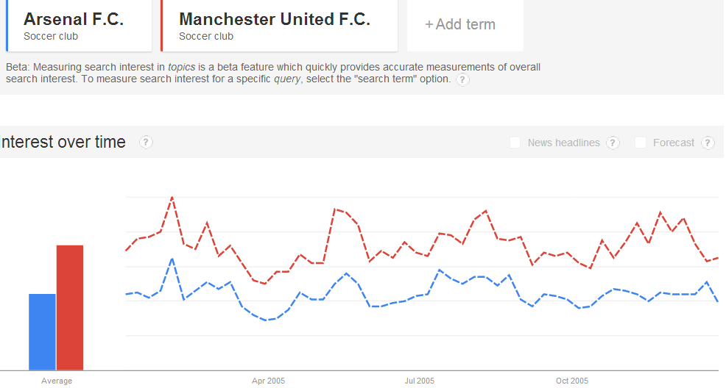 | Instruct students to load the ‘Explore’ page. Tell them that we can compare any terms we want and see how popular they are/have been on Google. Talk through the top toolbar (that filters your search), and briefly do an example comparison:  e.g. In May 2005, what was a more popular search item – Arsenal or Man Utd?  After explaining the process of displaying this information, give students a quick challenge to do on their own computers:  Last week, there were more Google Image searches for…  a) Miley Cyrus b) Beyonce c) Paul McCartney  Check students access the information correctly and get the overall concept of Google Trends before continuing! | 4 mins  4 mins
Resource practice  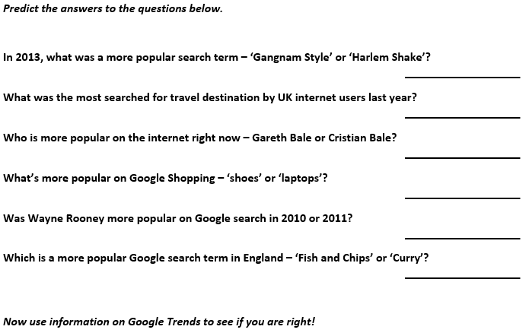 | Give students the list of 6 questions based on Google Trends searches.  First, ask them to predict the answers, and compare predictions with their partner. Then, they can work with their partner to find the answers using varied settings on Google Trends (Explore).  Class Feedback | 8 mins
Presentation  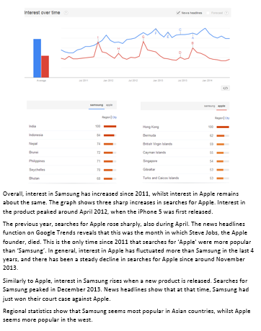 | Explain to students that you have researched the popularity of two companies that they know well: Samsung and Apple.  Q: Since 2011, which company has been more popular GLOBALLY?  Students predict, brief feedback.  Access ‘Explore’ on Google Trends and display a graph comparing Apple and Samsung since 2011 (it might be good idea to have this ready in a window at the start of the lesson).  Tell students that you will describe the data.  General Q: What gestures do I use during the presentation?  Present the information (on the hand out) to the students as clearly as possible. It might be best to practise this beforehand. Make very explicit gestures such as pointing at certain areas on the graph, hand gestures, eye contact, positive body language that engages the audience, etc.  After the presentation, ask students to feedback on the gestures they noticed. Board their ideas for reference later | 2 mins  3 mins approx.  4 mins feedback
Presentation – Vocabulary Focus  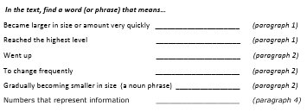 | Hand out a copy of the presentation you read.  Draw attention to the vocabulary activity. Give students time to search for certain key vocabulary in the text.  Clarify meaning, form (plus collocations), pronunciation (stress), etc.  Explain that students will be using this vocabulary for the next activity  Ans: Increased, peaked, rose, fluctuated, a steady decline, statistics | 10 mins
Practice | Students work in pairs to create their own presentation on 2 or more items to compare using Google Trends.  Direct students to the ‘Analysing and Presenting Data’ activity. Give a chance to read the instructions and ask any questions.  Remind students that they will be presenting their findings. They should use the preparation time to practise the delivery of their findings too.  Remember, students should share the speaking in the presentation | 20 mins
Production | Students deliver their presentations to the class.  They should display the graph from Google Trends on the main classroom computer so it is easy to see.  Active listening activity: ask other groups to make a table, where they have rows for ‘preparation, content and presentation’. They will mark other groups on the quality of their presentation, and compare/discuss their scores with other pairs.  Include feedback to content  Follow-up questions:  Do you think Google Trends is reliable?  Are there any limitations with it?  How could it be used by businesses? | 15 mins (depends on class size)
Error Correction | Correct any production errors you note down during presentations/monitoring | Time remaining

