Level: Elementary/Pre-Int Time: 90 mins Skills/focus: Vocabulary, Study skills
Aims: To revise and use vocabulary for ordinal numbers and months of the year.
To develop socio-cultural knowledge of UK celebrations/events through researching on Google Doodle.

Resources: Students need devices to view Google Doodles online, at least one device per pair
A computer linked to a projector/IWB for the teacher to demonstrate activities is essential

Stage | Procedure | Time
Activate | Ask students to stand up, and to arrange themselves in order of their birth date, earliest to latest. When complete, ask them to read out their birthday. Monitor for any problems/errors | 3 mins
Introduction  Vocabulary revision | Quickly go through the ordinal numbers and months of the year (use flashcards, elicit dates, any technique you wish)  Board a series of key dates relating to yourself (including years if you want to practise those a bit). Explain that these dates are answers. Students make statements (or ask questions) to try and elicit one of the dates from you… e.g.  (Board: 25th July)  Student: is your birthday the 25th of July?  Teacher: No  Student: is your anniversary the 25th of July?  Teacher: Yes  Students then write 3 or 4 dates down in their exercise books. Their partner guesses what event the dates relate to | 5 mins  4 mins  4 mins
Introduce Google Doodle  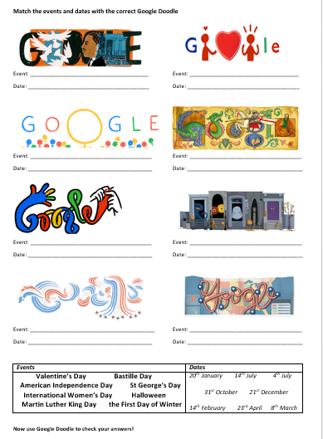  (Target Language Practice) | Access the Google Doodle page. Bring up a picture of a recent Google Doodle. Elicit what the image is and what it means. Ask students if they have seen these before, if they know any famous ‘doodles’, etc. Just check prior knowledge and clarify concept.  Show students one of the images from the Google Doodles handout (enlarged). Students work in pairs to guess what the event the image represents, and when the event is.  Conduct brief feedback  Give students the Doodles Handout – explain that they match the image to event and date. Students work alone first, then in pairs, then pairs can check with each other. Feedback, but don’t correct.  Then ask students to check there answers by searching on Google Doodle | 2 mins  2 mins  10 mins
Study skills practice  Target language practice  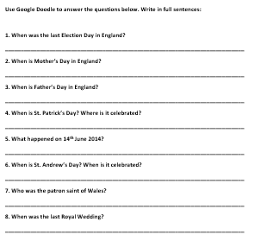 | Direct students to the research questions on UK events.  Students can work in pairs to find the answers using ONLY information on Google Doodle. They need to think of relevant search terms to explore the archive, you can model this if the class are particularly low level. Encourage students to answer the questions in full sentences.  Pair work, then feedback  Ask students how they think we celebrate these events, general discussion | 10 mins
Freer practice | Q: What are the important dates in your country?  Give students a minute to consider this, then they share their thoughts with a partner. Partners feedback on each other’s comments  Instruct students to search for Doodle’s related to their own country. Allow a few minutes for this, then get some feedback on their findings | 7 mins  5 mins
Break, fun activity | Students work in pairs. One member of each pair cannot see the board. Display one image from Google Doodles. Ask the student to describe the image to their partner, who draws it. Allow a few minutes, then get students to discuss what event the Doodle represents.  Change pair positions and repeat if desired | 8 mins
Follow-up activity | Ask students to think of either a) one important event in their life, or b) one important event in their country.  Students should design their own Google Doodle to represent this event, including important symbols. They should write a brief description next to their Doodle explaining what it represents. Model an example on the board if necessary.  Upon completion, students can show their Doodles to each other, first without showing the descriptions. Their partner can guess what the Doodle and its symbols represent. Class Feedback | 15 mins  10 mins
Error Correction | Time remaining

