
Match the events and dates with the correct Google Doodle


Event: _______________________________________ Event: ____________________________________
Date: ________________________________________ Date: _____________________________________
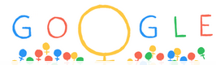
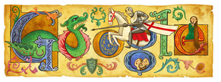
Event: ________________________________________ Event: _____________________________________
Date: _________________________________________ Date: ______________________________________
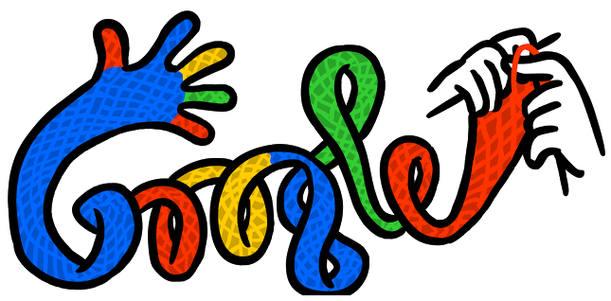
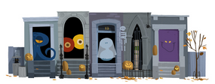

Event: ________________________________________ Event: _____________________________________
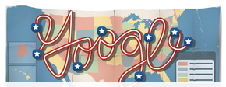

Date: _________________________________________ Date: ______________________________________

Event: _________________________________________ Event: _____________________________________
Date: _________________________________________ Date: ______________________________________

Events | Dates
Valentine’s Day Bastille Day  American Independence Day St George’s Day  International Women’s Day Halloween  Martin Luther King Day the First Day of Winter | 20th January 14th July 4th July  31st October 21st December  14th February 23rd April 8th March

Now use Google Doodle to check your answers!
Use Google Doodle to answer the questions below. Write in full sentences:

1. When was the last Election Day in England?
____________________________________________________________________________
2. When is Mother’s Day in England?
____________________________________________________________________________
3. When is Father’s Day in England?
____________________________________________________________________________
4. When is St. Patrick’s Day? Where is it celebrated?
____________________________________________________________________________
5. What happened on 14th June 2014?
____________________________________________________________________________
6. When is St. Andrew’s Day? When is it celebrated?
____________________________________________________________________________
7. Who was the patron saint of Wales?
____________________________________________________________________________
8. When was the last Royal Wedding?
____________________________________________________________________________

